MC

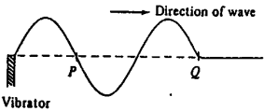

A vibrator generates a travelling wave on a string. The above diagram shows the shape of the string at a certain instant. Which of the following shows the shape of the string between PQ after a quarter of a period?

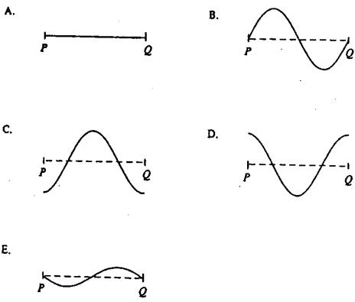

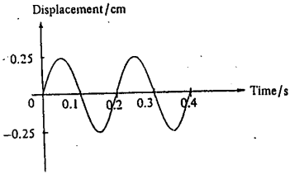

A train of water waves is generated in a ripple tank. The above graph shows the variation of the displacement of a cork placed in the water with time. Find the frequency of the waves.

A. 0.2 Hz
B. 0.25 Hz
C. 4 Hz
D. 5 Hz
E. 10 Hz

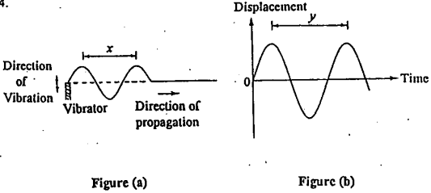

A vibrator generates a travelling wave on a string. Figure (a) shows the shape of the string at a certain instant. Figure (b) shows the variation of the displacement of a certain particle on the string with time. Which of the following expressions represents the speed of the travelling wave?
A. x
B. y
C.
D.
E. xy

A cork in the water vibrates up and down 4 times in 2 s when a wave passes through it. The distance between two successive crests of the wave is 10 cm. Find the speed of the water wave.

A. 0.05 m s⁻¹
B. 0.1 m s⁻¹
C. 0.2 m s⁻¹
D. 0.4 m s⁻¹
E. 0.8 m s⁻¹

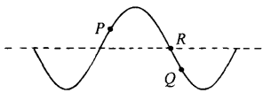

The above diagram shows a transverse wave travelling along a string. At the instant shown, particle P is moving upwards. Which of the following statements is incorrect?

A. The wave is travelling towards the left.
B. Particles P and Q vibrate with the same amplitude.
C. Particles P and Q vibrate with the same frequency.
D. Particle Q is moving downwards at this instant.
E. Particle R is at rest at this instant.

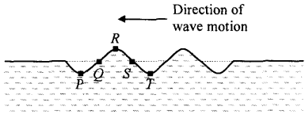

Five corks are moving up and down on the surface of a pond as a water wave passes through them. At time t = 0, the positions of the corks are shown above. The figure below shows the displacement-time graph of one of the five corks. Which cork has the motion represented by the graph?
(Note: Displacement is positive when the cork is above the still water surface.)

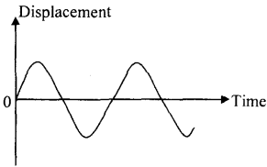

A. P
B. Q
C. R
D. S
E. T

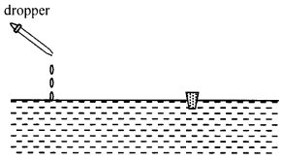

A cork floats in water and a dropper is used to produce circular waves as shown above. Which of the following describes the motion of the cork when the waves pass through it?

A. moves towards the dropper
B. moves away from the dropper
C. vibrates vertically about its original position
D. moves away from the dropper and vibrates vertically at the same time

(For Q8 and Q9) The displacement-distance graphs of the particles along a travelling wave at time ands are shown below.

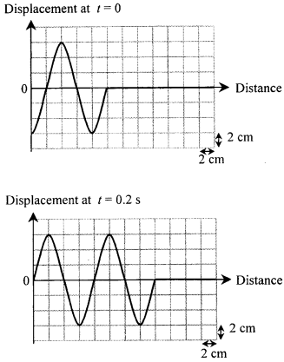

Which of the following statements about the wave are correct?

(1) Its amplitude is 6 cm.
(2) Its wavelength is 8 cm.
(3) Its frequency is 5 Hz.

A. (1) and (2) only
B. (1) and (3) only
C. (2) and (3) only
D. (1), (2) and (3)

What is the speed of the wave?

A. 0.2 m s⁻¹
B. 0.3 m s⁻¹
C. 0.4 m s⁻¹
D. 0.8 m s⁻¹

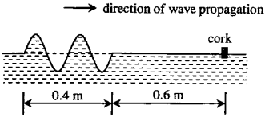

A cork is floating on a calm water surface. At time t = 0, a water wave is travelling towards the cork with a speed of 0.2 m s⁻¹ as shown in the figure above. When will the cork rise to its highest position for the first time?

A. 3.00 s
B. 3.50 s
C. 3.75 s
D. 4.00 s

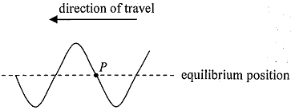

A wave travels along a string to the left. The figure above shows its waveform at time t = 1 s. Which of the following displacement-time graphs best represents the motion of particle P? (Take displacement upward to be positive.)

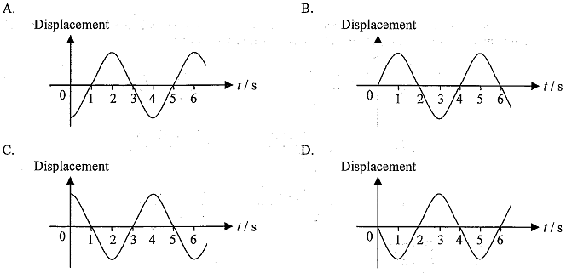

(For questions Q12 and Q13) The figure below shows the displacement-distance graph of a wave travelling to the right with speed 2 cm s⁻¹ at a certain instant. P and Q are two particles at distances x = 8 cm and 18 cm respectively.

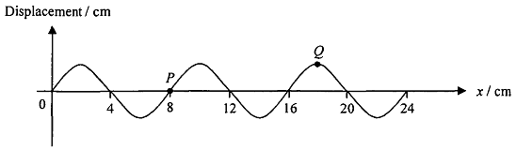

What is the period of the wave?

A. 0.25 s
B. 4 s
C. 8 s
D. 18 s

What is the shortest time for P to have the same displacement as Q at the instant shown?

A. 1 s
B. 3 s
C. 4 s
D. 5 s

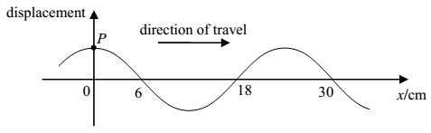

The figure shows a snapshot of a section of a continuous transverse wave travelling along the x-direction at time t = 0. At t = 1.5 s, the particle P just passes the equilibrium position for a second time at that moment. Find the wave speed.

A. 20 cm s^{–1}
B. 12 cm s^{–1}
C. 6 cm s^{–1}
D. 4 cm s^{–1}

CE 2009-10
In a ripple tank, initially five tiny plastic beads (P, Q, R, S, T) float on the calm water surface. A vibrator begins to produce straight waves at time t = O. Figure 12 shows the positions of beads on the waves at t = 7 s. Figure 13 shows the displacement-time graph of S.

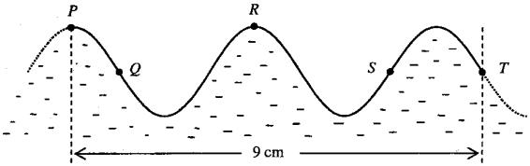
Figure 12

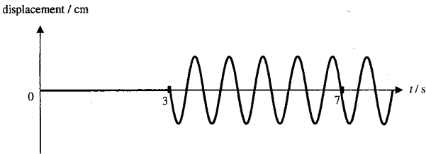
Figure 13

(a) (i) Find the wavelength of the wave. (1 mark)

(ii) Find the frequency of the wave. (2 marks)

(iii) Find the distance between the vibrator and S. (3 marks)

(b) State the bead(s) that is/are moving

(i) in the same direction with T at time t =7s, (1 mark)

(ii) in the opposite direction with T at time t = 7 s. (1 mark)

(c) In Figure 12, sketch the waveform between P and T at a quarter of period after t = 7 s. Mark the position of S. (2 marks)

ANSWER

